3D Space reference
vortxGE

+--------------+ +--------------+
| Object Space | -> Model Transform -> | World Space |
+--------------+ +--------------+
+--------------+ +--------------+
| World Space | -> Viewing Transform -> | Camera Space |
+--------------+ +--------------+
+--------------+ +--------------+
| Object Space | -> Modelview Transform -> | Camera Space |
+--------------+ +--------------+

Object Space
It is the local coordinate system of objects and is the initial position and orientation. In order to transform object space, use :

// Transformations
void RotateMatrix( float angle, float x, float y, float z );
void TranslateMatrix( float x, float y, float z );
void ScaleMatrix( float x, float y, float z );

An example:
// Set transform
lsMatrix4x4 transmat;
lsMatrix4x4 rotmat;
lsMatrix4x4 scalemat;

transmat.TranslateMatrix( position.x, position.y, position.z );
rotmat.RotateMatrix( rotation.x, 1, 0, 0 );
rotmat.RotateMatrix( rotation.y, 0, 1, 0 );
rotmat.RotateMatrix( rotation.z, 0, 0, 1 );
scalemat.ScaleMatrix( scale.x, scale.y, scale.z );

openGL
Camera Space – ModelMatrix * ViewMatrix
GL_MODELVIEW matrix is a combination of Model and View matrices (). Model transform is to convert from object space to world space. And, View transform is to convert from world space to camera space.

vortxGE
In vortxGE I store the View and Model Matrix separate. You shouldn't have to worry about this as the engine handles it all for you inside the lsShader class.

Right handed Coordinates
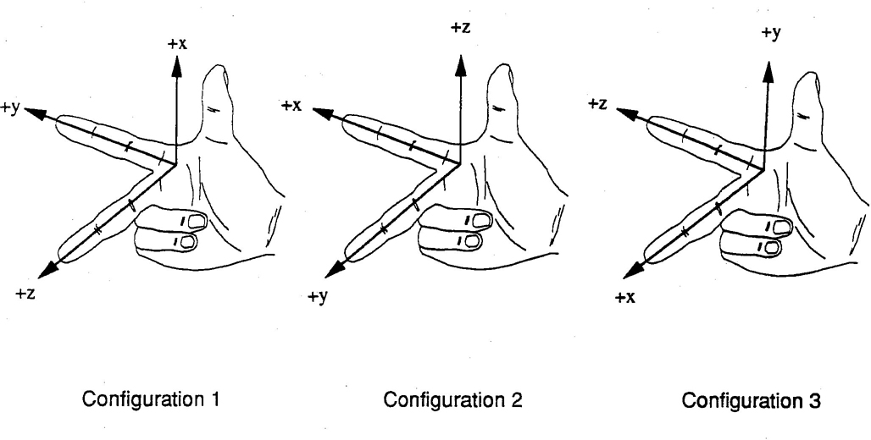
vortxGE uses configuration 3

